***Pull request / { table} / {ID}***

**Supports:**

* **User table**
* **Lessons table**
* **Slides table**

**Push request/{table}/{arr separated by “-”}**

**Note:**

* **you can use -- to input empty information into the database but you are required to keep the last position of the string nonempty**
* **You must have enough inputs as the size of the table**

**Supports:**

* **Lessons**
* **Users**
* **Feedback**
* **UserHistory**
* **Slides**

**delete request/{table}/{arr}**

**Supports:**

* **Lessons**
* **Users**
* **Feedback**
* **Slides**

**Push request/{table}/{arr separated by “-”}**

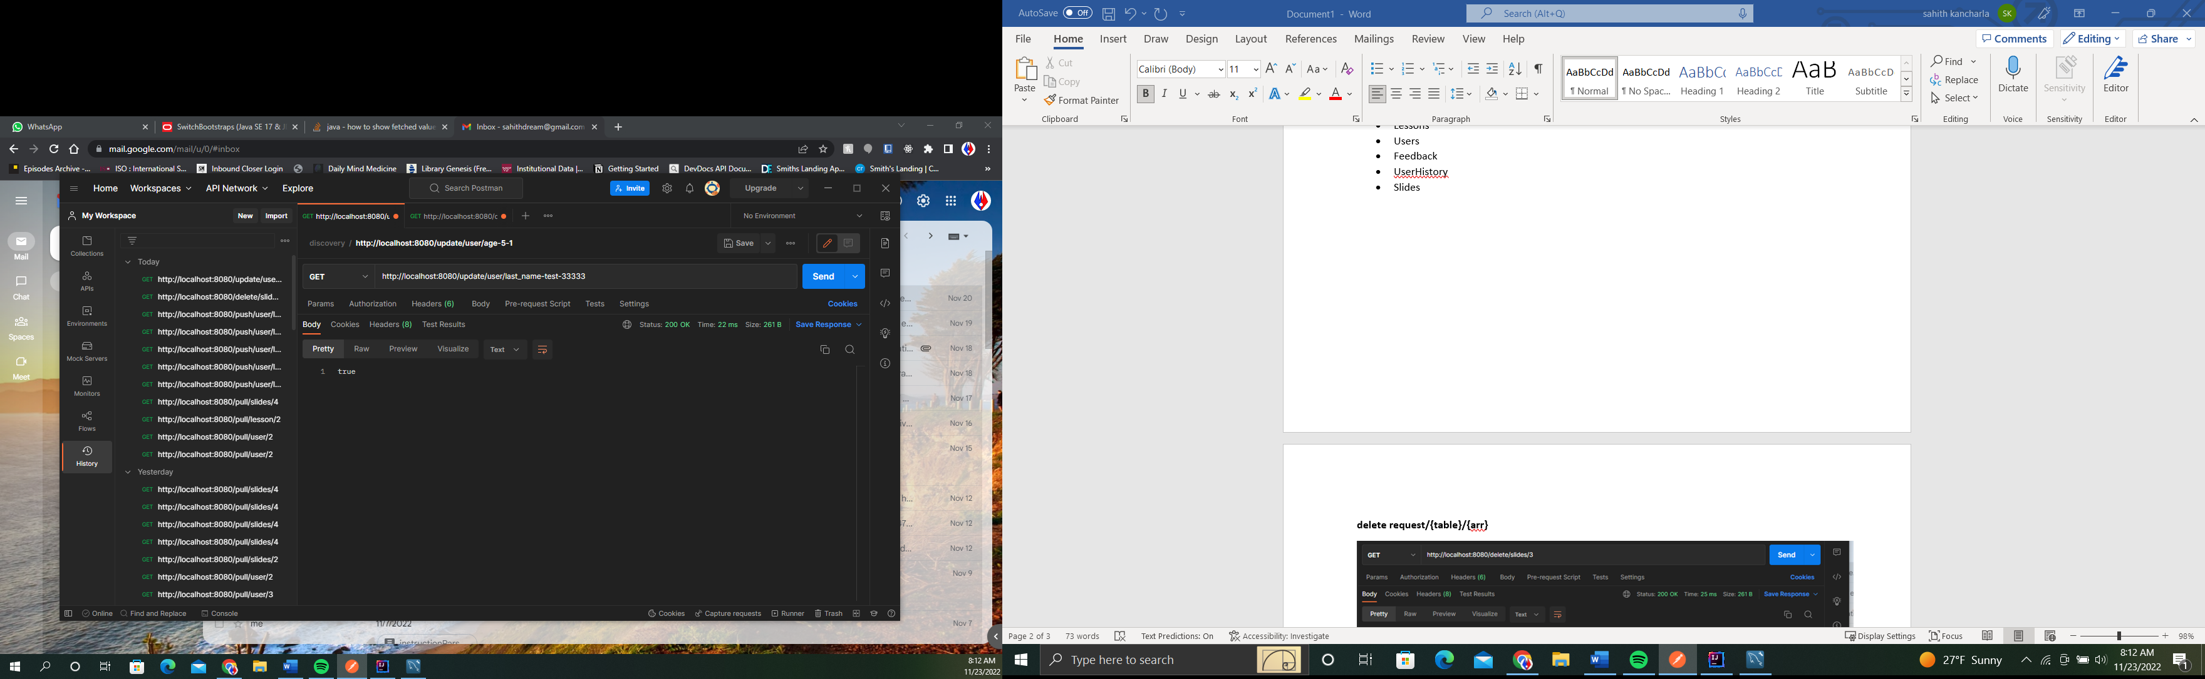

**Note:**

* **you can update as many fields as you want by using {field1-change1-feild2-change2… - ID} structure**

**Supports:**

* **Lessons**
* **Users**
* **Slides**

**Check/ {type}/ {arr}**

**Note that there are 2 types of checks:**

* **Type : login. This needs username and password as inputs**
  + **Returns true is the login is valid**
  + **Else returns false**
* **Type : username. This checks if the username exists in the system.**
  + **Returns True is the username is unique**
  + **Else returns false**